Complete Quality Manual
AM Manufacturing, Inc.
2283 Cole Street
Enumclaw, WA 98022

e: Melissa@AMManufacturingInc.com
www.AMManufacturingInc.com

DESCRIPTION | SECTION | PAGE
Scope of Manual | 1 | 3
QC Management Responsibility | 2 | 4
Order Processing | 3 | 5
Engineering Drawings | 4 | 6
Incoming Inspection | 5 | 7
Inventory Control | 6 | 8
First Article and Final Inspection | 7 | 9
Identification, Packaging, and Shipping | 8 | 12
Invoicing | 9 | 14
Equipment Calibration | 10 | 15
Corrective Action Procedures | 11 | 16
General Workmanship Standards | 12 | 18
Internal Audit System | 13 | 19
Training | 14 | 20
Revisions | 15 | 21

Scope of Manual
Section 1

  - The purpose of this manual is to demonstrate and document the ability of AM Manufacturing, Inc. to provide a consistently high quality of work in accordance with the requirements and expectations of our customers.

  - The quality control practices and standard operating procedures described in the manual apply to all aspects of our work, specifically including: order processing, work order creation, distribution of drawings or technical information, preliminary inspection, ordering/issuing of materials, all aspects of the machining process, final inspection, packaging, shipping and billing.

  - Equipment calibration is fundamental to ensuring high quality machining. The methods of obtaining and maintaining calibrated equipment are documented within.

  - AM Manufacturing, Inc. values a culture of continuous improvement. Any quality issues, whether internal or external, are indicative of an opportunity for improvement. The process for corrective actions described in this manual are to ensure that any issues the arise are dealt with systematically, evaluated thoroughly, and the processes are reviewed and amended when needed.

  - The internal audit system described herein, proactively verifies that all standard operating procedures are being followed on a routine basis.

  - All relevant documents to be included inline with their associated sections.

QC Management Responsibility
Section 2

  - The Secretary / Treasurer reports to the President and serves as the manager responsible for oversight and direction in regards to quality control.

  - The Secretary / Treasurer is responsible for the following in terms of managing quality standards:

- Communication of all expectations related to quality control issues.
- Investigation of all quality exceptions to determine the root causes.
- Identification and implementation of corrective actions necessary to resolve a quality exception.
- Responds to any customer inquiries regarding our quality control methods and procedures.
- Coordinates any customer-initiated audits of our quality systems.
- Oversees maintenance of calibration records for measuring equipment.
- Generation of customer specific incoming or outgoing inspection reports as needed, to be filled out by shop personnel.
- Ensuring work order instructions are consistent with customer expectations and all support documentation is made clear and available.
- Ensuring all appropriate drawings and technical information is clearly conveyed to the shop personnel.
- Ensuring appropriate materials are specified and used in adherence with customer requirements.

  - The HR and Compliance Department is directed and operated by the Secretary / Treasurer and reports to the VP and President and bears the responsibility of training personnel on the operations outlined in this QC manual and conducts audits for compliance.

  - All managers, supervisors, and employees are required to comply with all provisions of the Quality Manual as it relates to their specific operational responsibilities.

Order Processing
Section 3

  - All jobs, both quoted and time and material require customers to provide a Purchase Order (PO) or written authorization from a qualified customer representative before work can begin. Written Authorization incudes email communication stating to do so and delivery of materials and documentation

  - Any purchase orders received via email are to be sent to the attention of Melissa at am.manufacturingoffice@gmail.com or to the main business email address of am.manufacturing@gmail.com for processing.

  - All customer purchase orders or written authorizations are maintained in a folder and a copy is provided to the shop floor with support documents such as drawings, customer specs, time cards, and employee accountability documentation. All completed purchase orders have support documentation attached and are maintained for a minimum of seven (7) years.

  - Upon release of purchase order, the customer is to provide AM Manufacturing with any necessary support documents required to complete work such as drawings, customer specifications, and requirements. The PO is recorded into our office software for long term documentation and billing purposes and is given a company specific job number.

  - A work order is then generated in paper form along with a traveler which includes a copy of the PO, a job card with detailed information and employee/machine details, drawings, pallet/box tags, and inspection documents if required. The work order is to be reviewed by the shop supervisor or the employee running the job, if not both. In the event of a discrepancy, the customer will be notified immediately.

  - Once the traveler is placed on the shop floor it is placed into workflow and scheduled into manufacturing.

  - Changes to the scope of work of a job must be confirmed by the customer with a written authorization from a qualified representative

  - Any changes to the scope of work require a revised PO to be issued in writing for future records keeping purposes and to confirm changes. All existing work orders, travelers, and drawings will be pulled from production and replaced with revised documents.

Engineering Drawings
Section 4

  - All engineering drawings are downloaded and prints are laminated before going onto shop floor. Any time a revision occurs the previous revision is replaced by the new revised drawing and the old rev is destroyed.

  - A copy of the drawing used on each job is scanned into the computer for reference and history.

  - Any CAD drawings are scanned / downloaded and uploaded to the part number file for future reference.

  - Copies of drawings are distributed to the shop floor and are collected and filed or shredded as necessary at the end of each job.

Incoming Inspection
Section 5

  - All customer material is received and labeled and evaluated for correct measurements and is counted if possible. In the event the quantity cannot be immediately verified due to shipping constraints, any discrepancies will result in the customer being notified as soon as possible.

  - Customized incoming inspection processes can be developed by AM Manufacturing at the express consent of our customers.

Inventory Control
Section 6

  - Material handlers verify all incoming stock for correct dimensional accuracy and verify they match PO descriptions.

  - Once verified, AM Manufacturing owned materials are received into inventory and stored in their designated locations.

  - The types and quantities of materials to be stocked are determined by the purchasing department who review customer supplied estimated usage reports when provided.

  - All incoming material ordered for specific jobs are identified with an identifying number and the traveler is attached to that material in the staging area away from stock.

  - Raw material certifications will be provided to the customer only on a specifically requested basis. Certifications for material are labeled and filed in a 3-ring binder with part#, PO#, qty, and date recorded.

  - All materials are ordered via a purchase order placed through Purchasing.

  - Materials used on a job are to be designated as such by recording the part# and PO# of the job on the parts or by pulling material from stock to fulfil a customer PO.

  - Material inventory is audited quarterly for correctness of type and quantity versus system records.

First Article and Final Inspection
Section 7
  - All work is to be performed in accordance with customer specifications.

  - In the event a customer drawing is unavailable, work is to be performed in accordance with the specifications documented on the work order with information provided on the purchase order, from working sketches, per customer instructions.

  - Upon receipt of job, if requested a first article inspection will be performed. With some parts needing multiple operations performed, it is possible for the part to fail first article inspection in the final operation. At that time, the customer will be notified of the non-conformance with a SCAR and it will be sent to the customer for instruction on how to continue. When it is determined by the customer that work can continue, any adjustments requested will be performed and work will continue.

  - Upon completion, all work must be final inspected by the employee performing the work. Customer supplied final inspection sheets will be used if provided if the request is made at the time of quoting or ordering.

  - For new parts made, the scope of final inspection is to include machined features and drawing dimensions. For orders of multiple parts a sample of 10% will be inspected. All critical dimensions are measured continually throughout the machining process.

  - In the event parts contain features that cannot be measured with conventional measuring tools, a plan for inspection will be devised by shop management.

  - Customized inspection programs for equipment or projects will be developed as requested by the customer. Such requests must be made prior to quoting.

  - In-process inspection will be performed after each manufacturing process. Job specific expectations for any in-process inspection will be supplied by engineering or shop management.

  - At the completion of each job the assigned supervisor is to review the work to verify customer specifications and that work has been carried out as instructed on the work order and that all work was performed with good workmanship. A certificate of conformance can be completed if requested by customer on the PO.

INSPECTION REPORT
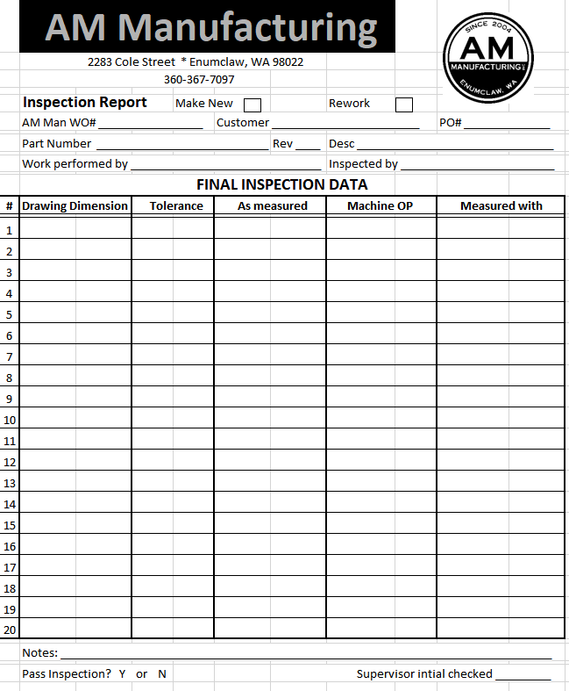

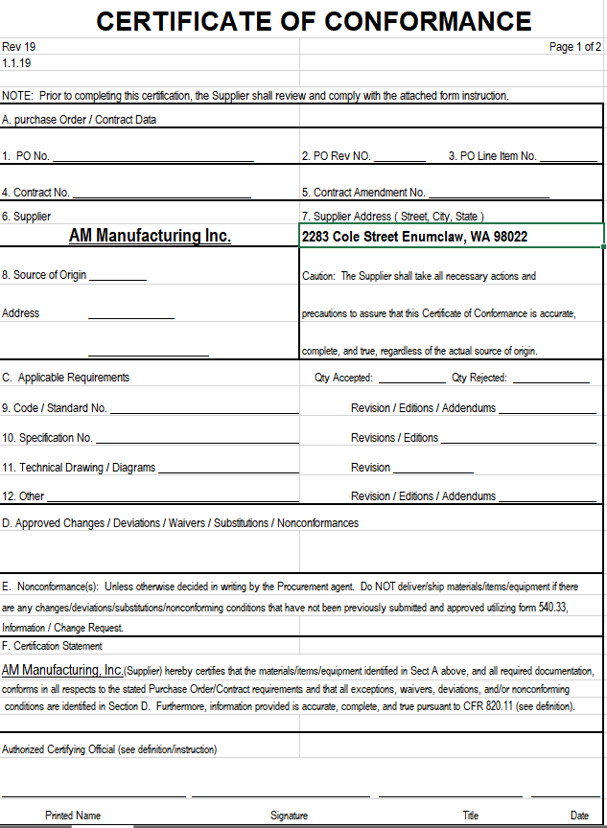

Identification, Packaging, and Shipping
Section 8

8.1 All work is to be clearly marked with the part number and quantity immediately upon arrival.

8.2 A work order or traveler are to be generate in a timely manner once the scope of work is determined.

8.3 The traveler is to be sleeved and placed with material on the shop floor or in storage if a stock item. It is to stay with the work throughout the entire manufacturing process. In the event that a job is divided among work stations, multiple copies of the traveler are to be distributed so that each person working on the job has all available and important job documentation.

8.4 On completion, all work to be packaged in accordance with purchase order instructions. In the event that no specific packaging instructions are specified on the PO AM Manufacturing will package using industry standard measures such as a box or pallet.

8.5 No rust preventative compound will be applied to parts unless specified by customer PO.

8.6 Work received in customer supplied containers, it will be returned in the same container whenever possible.

8.7 On quoted jobs the shipping method is defined on the quote. Additional shipping charges may be incurred and added to the cost of the purchase order if outside of our scope of delivery expectations.

8.8 When a job is delivered to a customer, they are given a copy of the packing slip, parts are tagged with part# and PO#. A signed packing slip is obtained and is kept with job files at AM Manufacturing to document the delivery of the job to the customer. A copy of any other inspections or non conformance reports are delivered with parts and a copy is kept with the job.

8.9 Material certs are filed and retained for a minimum of 5 years and a copy is kept with material

Job Card and Pallet Tag

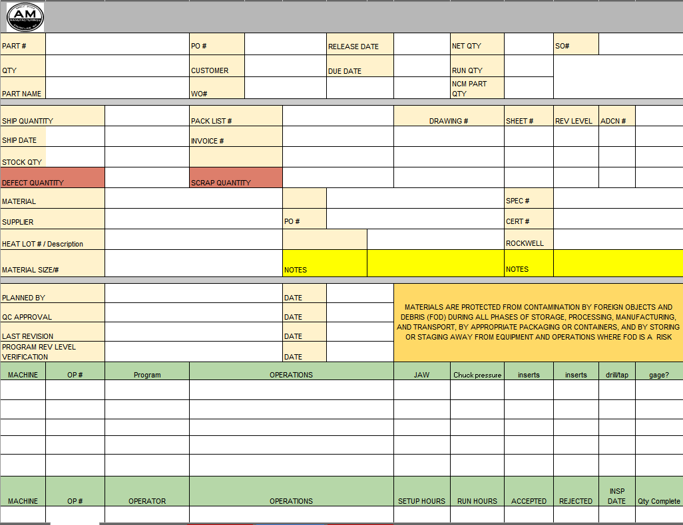

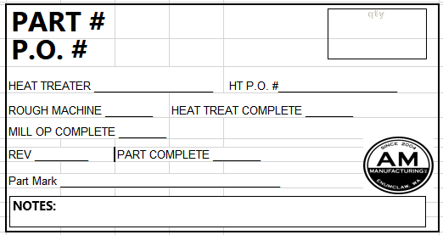

Invoicing
Section 9

9.1 Our job is not finished until the invoice is sent and our goal is that all invoices will be sent promptly and accurately to the appropriate contact.

9.2 Each invoice is expected to have a clear description of the services rendered with any and all referencing numbers for easy understanding and tracking.

9.3 On Time and Material jobs, a price update is available at any time upon customer request prior to completion.

9.4 Appropriate customer documents, such as PO number, WO number, or serial numbers will be referenced on the final invoice.

Equipment Calibration
Section 10

10.1 A specified area is maintained for the control of tooling and gages. A system is in place for calibration of any and all measuring equipment used at AM Manufacturing and records are maintained by management.

10.2 All standards are certified yearly. Certification documentation is kept on file in the office and are available to customer review upon request.

10.3 All micrometers, both personally and company owned are set to standards each time a micrometer is used to measure parts.

10.4 New employees are trained daily and monitored to ensure all necessary personnel now how to properly set and use measuring equipment.

10.5 Quality checks are performed on machines as part of a preventative maintenance program biannually or as symptoms are observed. Any problems are immediately dealt with and rectified.

10.6 Reference the Master Calibration List to see a full list of all calibrated equipment. Available upon request.

Corrective Action Procedures
Section 11

11.1 All possible precautions are taken to assure that quality exceptions never occur. In the event that an exception does occur, the highest priority is given to getting an acceptable part to the customer as soon as possible.

11.2 As part of our continuous improvement philosophy, any quality exception is viewed as a potential to improve.

11.3 For any quality exception, whether discovered internally or by a customer, a rework analysis is performed by supervisors. The purpose of this analysis is to understand the root cause of the issue and to identify measures that need to be taken to assure that similar issues are avoided in the future.

11.4 The rework analysis is performed by supervisors, programs are reviewed, tooling is inspected, any drawings are analyzed to determine the root cause and notations/corrections are made to avoid future repetition of this non-conformance.

11.5 All reworked parts are to be documented on a SCAR (supplier corrective action report) and returned to the customer with the parts with a copy being delivered with the parts.

11.6 Root causes, identified on the SCAR, are logged into a database for tracking.

11.7 All rework hours are flagged as such for tracking purposes.

SCAR REPORT
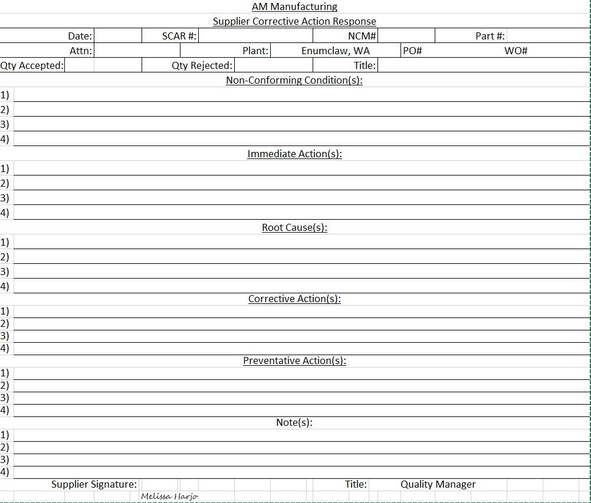

General Workmanship Standards
Section 12

12.1 Unless otherwise indicated on engineered drawings, all shop work is to conform to the general workmanship standards.

12.2 Machining:
a. All machined surfaces are to be without dings, scratches, and will conform to the finish standards set forth on the drawing
b. All sharp edges are to be broken and deburred

12.3 Grinding:
a. All ground surfaces are to have an acceptable finish unless it is specified on the drawings in a specific callout.
b. All ground surfaces are to be done to notable quality standards free of chatter and lines
c. All sharp edges are to be broken and deburred

Internal Audit System
Section 13

13.1 An internal audit system is in place to verify that all policies and practices outlined in this manual are being carried out as specified.

13.2 The Secretary/HR manager bears the responsibility for conducting and reviewing these processes and internal audits.

13.3 Full audits are to conducted at least once per year. Partial audits may be conducted if concerns of adherence to specific areas arise.

13.4 Once complete, audits are reviewed by management. Any concerns identified during the audit are addressed by the supervisor.

13.5 All completed audit paperwork will be kept on file with the HR department with the revisions noted on the manual.

TRAINING
Section 14

14.1 All employees are to be trained on the contents of this manual when hired and specific items will of the manual will be reviewed with all supervisors and employees at a monthly company meeting and comments will be documented along with attendance.

14.2 Each employee is given a copy of this manual for reference.

14.3 Follow-up training is carried out in the event of a revision change to this manual.

14.4 The training program is conducted by the Secretary/HR director with daily follow up by shop superviors.

REVISIONS
Section 15

15.1 All revisions are documented below at the time of revision.
15.2 The revision number of the document is to be displayed in the footer of each page and will be updated with each revision.

Rev# | Date | Section | Decription of change

